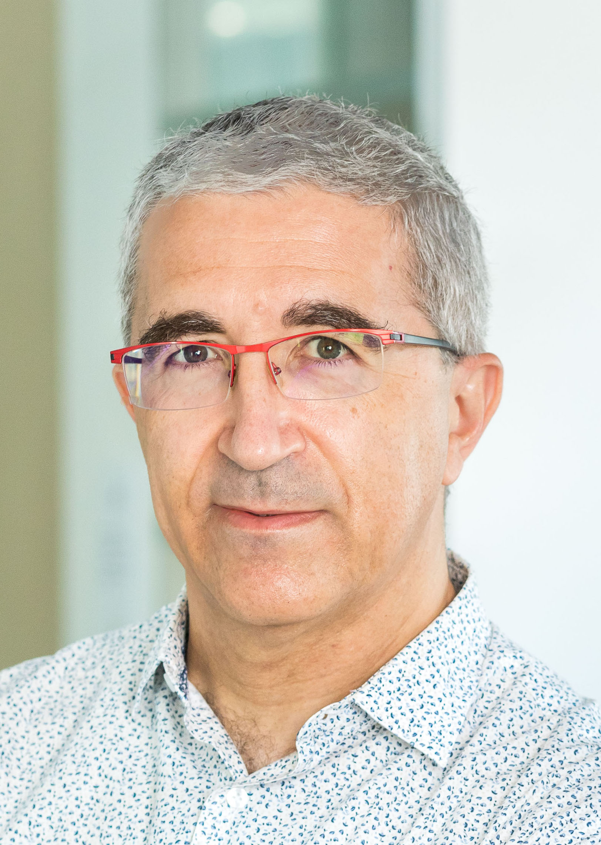
Renaud Marlet is a scientist specialized in IT. He graduated from École polytechnique in 1988 and obtained a Ph.D. degree in computer science in 1994 from Université Nice-Sophia-Antipolis. He has held positions both in academia (researcher at INRIA) and in the software industry (expert and project manager at Simulog, deputy CTO of Trusted Logic), where he worked on programming languages, software engineering, security and computational linguistics. Since 2009, he has been a Senior Researcher at École des Ponts ParisTech (ENPC) in the Computer Science lab (LIGM), heading the IMAGINE research group (2010-2019) and working on computer vision for robotic applications in the context of civil engineering as well as safe driving and autonomous vehicles, using both 2D and 3D data. Since 2019, he has also been a Principal Scientist at valeo.ai. He has published 3 books, 8 patents, and more than 50 papers in major peer-reviewed international journals and conferences.

[Last update: 2022-07-08]

